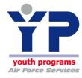
Holloman AFB Youth and Teen Center

Youth name: ____________________________________________________ Grade: _________________

Sponsor’s status (check one of the following)

Active Duty Air Force |  | Coast Guard
Active Duty Army |  | DOD Civilian
Active Duty Navy |  | Contractor
Active Duty Marines |  | Retiree
Reserve |  | Other
National Guard

Annual (12 months) membership fee | $48.00
Summer only (June-August) membership fee | $30.00
Non-Members: Open Recreation | $5.00 per day
Benefits of being Youth and Teen Center member:
- Daily admittance to Open Recreation programs and activities
- Occasional FREE activities, programs, & field trips that would normally require a fee and reduced prices on other activities
- Opportunities to grow in the areas of Character & Leadership, Career & Education, The Arts, Sports & Fitness, and Health & Life Skills
- Safe, affordable, available, and quality programing for youth during the afterschool hours

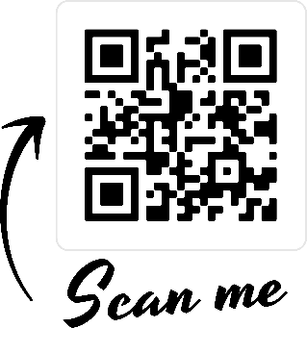
Like us on Facebook for the most up to date information on Teen Center events and activities, field trips and need to know information

page left intentionally blank
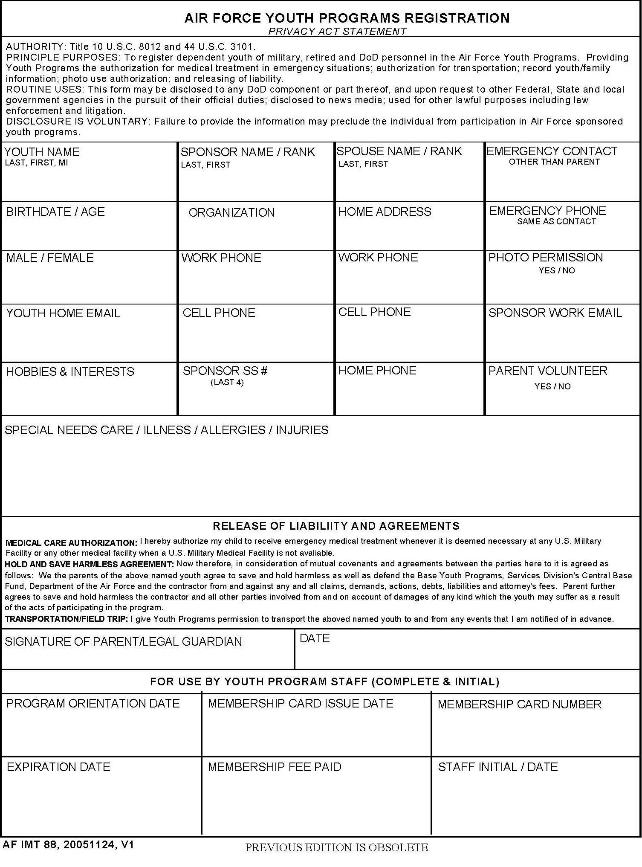
page left intentionally blank
Holloman Airman and Family Services
Youth Center
Special Needs Information
The Holloman AFB Youth and Teen Center will not discriminate against enrolling children with special needs. However it is imperative that we know what types of special needs your child may have so that we may provide the best care possible.
_______________________________________________________
Child’s Name (Please Print)
Has your child been diagnosed with any of the following? (Please check all that apply)
 | Visual Problems |  | Feeding issues (reflux, poor feeding, Etc.) |  | Allergies (meds, food, environmental)
 | Hearing Problems |  | Diabetes |  | Asthma/Respiratory Problems
 | Visual impairments/Blindness |  | Speech/Language Delays |  | Emotional Disturbance
 | Orthopedic impairments |  | Autism Spectrum Disorder/PDD |  | Kidney Problems
 | Specific Learning Disability |  | Physical Disabilities |  | Developmental Delays
 | Oppositional Defiance Disorder (ODD) |  | Attention Deficit/Hyperactivity (ADHD/ADD) |  | Heart Problems
 | Hemophilia/Sickle Cell |  | Multiple Disabilities |  | Other
 | Epilepsy/seizures (to include febrile) |  | Intellectual Delays

Please answer the following questions (Circle YES or NO)
- Has your child ever been hospitalized? YES NO
If YES, Please Explain:_____________________________________________________________________________________ ________________________________________________________________________________________________________
- Is your child taking ongoing medication? YES NO
If YES, Please Explain: ____________________________________________________________________________________ _______________________________________________________________________________________________________
- Does your child have any known allergies (including pets)? YES NO
If YES, Please Explain: ____________________________________________________________________________________ _______________________________________________________________________________________________________
- Has your child ever been diagnosed with any special needs to include having an IFSP, IEP or an EFMP?
YES NO
If YES, Please Explain: ____________________________________________________________________________________
_______________________________________________________________________________________________________
- Do you have any special concerns about your child’s development that you would like us to pay particular attention too? YES NO
If YES, Please Explain: ____________________________________________________________________________________ _______________________________________________________________________________________________________
If you answered yes to any of the above questions, you may be asked to complete an Air Force Child and Youth Programs Medical Inclusion Questionnaire. This questionnaire will be reviewed by the Inclusion Action Team prior to admittance to the program. Children with special needs require more than routine and basic care. This includes with or at risk of disabilities, chronic illness and/or physical, developmental, behavioral, or emotional conditions requiring additional health and/or related services. (Reference AF School-Age Program Inspection Criteria S153, AF Youth Programs Inspection Criteria Y107)
page left intentionally blank

Holloman AFB Youth and Teen Center Registration Form

Instructions: Parent/Guardian and Youth need to read through each statement in its entirety. A parent/guardian and the youth are both required to initial next to each statement indicating that they have read and understand the statement. It is recommended that parents/guardians and the youth read through the document together and discuss the issues so that there is complete understanding. Questions about the statements or any portion of the contract need to be brought to the attention of the Teen Center Manager or the Youth Programs Chief.
Initials
Parent Youth
a. MISSION STATEMENT: To assist DoD military and civilian personnel in balancing the competing demands of accomplishment of the DoD mission and family life by managing and delivering a system of quality, available, and affordable programs and services for eligible children and youth birth through 18 years of age.

b. PURPOSE: The purpose of the Youth and Teen Program is to provide social and recreational activities that are age appropriate, educational, and entertaining for youth when school is not in session. Please note: The Youth and Teen Center is NOT childcare. Youth have more freedom and more levels of responsibility and therefore have greater expectations on issues related to maturity and accountability. Statements below will address these issues.

c. ELIGIBILITY: Sponsored dependents of active duty, DOD civilians, active Reservists/Air National Guard, contractors, and retired military are eligible for enrollment. The Youth and Teen Center is designated for youth age 9 to 18 and still in High School. Seniors who graduate at the beginning of summer may continue to attend the center until the last day of summer prior to the start of the new High School year.

d. FEE INFORMATION: Currently, fees for membership are $48 per year, per person and due at the time of registration and then again on the anniversary date of the initial registration. Seasonal summer only enrollments are $30 and cover the time period of June through August. Under no circumstances will enrollment fees be pro-rated or refunded if a youth decides not to come to the center or if a parent decides youth no longer needs to come to the center. Special activities such as field trips may have an additional cost associated with them. Payment for these activities is due at the time of registration.

e. MEMBERSHIP CARDS: Youth are issued a membership card at the time of registration. Youth are required to sign in and out of the program with their membership card daily. Failure to bring membership card will result in the loss of checking out privileges. After 3 consecutive days of not bringing their membership card youth will not be permitted to attend the program until they have replaced their membership card or found their old one and are able to sign in with their card. Replacement cards are $4.

f. ACCOUNTABILITY: Youth safety is a number one priority and it is required that all youth must be accounted for when they are in our program. Youth are required to sign themselves in & out of our programs using the card issued at time of registration. Other youth, siblings, and/or parents are not allowed to sign youth in and out of the program. This process is the responsibility of each youth and they need to take ownership of the process and develop the habit themselves. AFI 34-144 section 12.14.3. States Youth, 9 years of age and older participating in open recreation/teen program may sign themselves in and out of the YP facility without parental oversight. Please note: Youth Programs staff CANNOT prevent youth from signing themselves out of the program and leaving the center, even if the desire of the parent is for the child to stay at the center.

g. LATE PICK UP: Unlike the CDC and SAP, Preteen and Teen programs are not childcare programs. When the scheduled operating hours or program event/activity have concluded the facility will close. If a parent has not come to pick-up their youth, the youth will be required to sign themselves out of the program and leave the site. Youth will be given the option to call a parent or other phone numbers prior to closing in order to locate a parent or guardian. Youth Programs staff are not required to stay with the youth once the program/facility closes.

h. HEALTH AND ILLNESS: The program will not accept Youth into the program who are exhibiting signs of illness. If your child has been exposed to a contagious illness, please notify the supervisor on duty. If your youth becomes ill while in the program, you will be called to pick him/her up from the program to prevent others from being exposed. The youth must be picked up immediately upon notification. Depending on the nature of the illness, your youth may be required to provide a medical evaluation before readmission to the program.

i. HYGIENE: Parents: Please be aware that youth in this age group have multiple issues related to personal hygiene. This can be everything from body odor as a result of physical activity to the beginnings of menstruation for young girls. Please discuss personal hygiene with your youth, and ensure that they are taking the necessary steps to be prepared. This includes having deodorant and any other personal hygiene items in their belongings in the event a need arises. Youth Programs will not have these items available.

j. MEDICATIONS: Medications can be administered in the program with proper documentation only. Parents must work with Program Manager to complete an AF Form 1055 and initial the form daily, indicating when medications are to be administered. Medications will not be administered if the AF Form 1055 has not been initialed for that day. “As needed” and emergency medication must be initialed by the parent/guardian upon completion of AF Form 1055. If it is necessary to use them, the program will contact the parent by phone and receive confirmation to administer the medication. Under NO circumstances are youth allowed to share medication with any other youth, including over the counter medications such as cough drops.

k. SPECIAL NEEDS: Youth with Special Needs, including dietary restrictions and allergies, are required to have the program’s Medical Advisor complete a Recommendation for Care form. Enrollment into the program may be delayed while the recommendations are reviewed and/or accomplished. Failure by families to maintain current and complete documents may result in denial of participation in program until forms are brought up-to-date.

l. EMERGENCIES: For youth who experience health problems or injuries while in the program, parents will be notified about the situation. Parents will be contacted immediately for serious accidents or illness. In the event that a parent/guardian cannot be contacted, Youth Program staff will attempt to contact the person listed as the Emergency Contact on the AF88. It is for this reason that the emergency contact person cannot be a parent or sponsor and that the information provided must be accurate and current. The supervisor on duty will determine if the youth is to be removed from the program. An ambulance will be called for youth who have conditions requiring medical attention beyond basic first aid. Accidents will be reported on AF Form 1187, Youth Flight Accident Report. Parents are required to read and sign the report. If your youth is seen by a doctor and/or requires hospitalization, parents are required to notify Youth Programs immediately.

m. SMOKING/SMOKELESS TOBACCO/VAPING: Smoking and/or the use of smokeless tobacco is not permitted for both youth and adults in or around the Teen & Pre-teen Program. Smoking by adults is not permitted within 50 feet of any Youth Programs building, activity, or event. Use or possession of tobacco products in Youth Programs may be grounds for a removal from the program.

n. DRUGS, ALCOHOL, & WEAPONS: Alcohol, illegal drugs and weapons of any kind are not allowed in Youth Programs facilities or YP sponsored trips and events. Use or possession of any of these items in Youth Programs may be grounds for removal from the program.

o. TRANSPORTATION AGREEMENT: Sponsors give permission for the program to transport their youth to and from program locations for field trips, emergencies, etc. Air Force and/or contracted vehicles will be used in all cases except emergencies when the most expedient means of transportation will be used. Staff members who transport youth must have a valid driver’s license and a good driving record. Field trips requiring transportation may be either on or off base. At no time will staff be allowed to transport youth in a privately owned vehicle.

p. DRESS CODE: Please make sure your youth dresses in appropriate clothing. We may send your youth home to change clothes if the clothing is deemed inappropriate by the Youth Programs staff. Inappropriate clothing includes, but is not limited to: shorts/skirts that are too short, clothing with excessive holes, shirts with inappropriate or profane advertisements, open-toed shoes, etc.

q. PERSONAL ITEMS: We discourage youth from having valuables with them or carrying them in their belongings. This includes large amounts of money or other personal belongings, especially electronics. The program will not be held accountable for lost or stolen articles. The Youth and Teen Program maintains a lost and found container. Any items left over 30 days may be donated to the Airman’s Attic. We recommend that all personal belongings are clearly marked with the youth’s name.

r. PHOTO/VIDEO RELEASE: For many of our activities we take photos and videos to document experiences. All photos taken may be used in specific reference to Youth Programs for training, documentation, or recognition of the program. Photos may also be used for display throughout our programs. Photos and videos WILL NOT be released or used for external marketing purposes unless authorized on the AF88.

s. AGE APPROPRIATE MATERIALS: Age appropriate materials will be used in the programs. Teen Programs will show PG-13 movies and below and have other items that are rated Teen. Pre-teen activities will show PG* and below movies and have materials that are age appropriate.

t. CLOSED CIRCUIT TELEVISION (CCTV): The CDC/SAC/Teen Center uses a CCTV surveillance system and recordings may be made regarding the program's daily activities. In the spirit of openness, parents/guardians may come to the program to view their child/youth participating in events in real time on the CCTV monitor. Once CCTV recordings are made, the recording becomes an official Government record. Requests by parents/guardians for viewing CCTV recording may be made to the program's Director.

u. ORIENTATION: I received an orientation upon enrolling my child(ren) in the Youth and Teen program that included meeting the staff, a tour of the building and an overview of the programs and activities offered.

Behavior Guidelines and expectations

All youth who attend the Youth and Teen Center must adhere to these guidelines and expectations in order to have continued access to the center. Failure to adhere to these guidelines and expectations will result in appropriate consequences for a duration to be determined by the Program Manager. Serious offenses may result in a suspension from the program. If an offense requires long-term expulsion from the program, determination will be made by the Youth Programs Director. Approval of complete removal from program, will be made by the Family Member Programs Flight Chief.

The following list of behavior expectations is required of all youth who attend the program. Each youth will:
a. Respect the Staff who work and operate the Preteen and Teen Center
b. Respect the other youth who attend the Preteen and Teen Center
c. Respect the physical property of the Preteen and Teen Center, including the building, grounds and equipment.

Respect is defined as: ‘To consider with high regard and esteem, and to refrain from interfering with.” Since different people approach respect from different positions, the position of reference is that of the Program Manager and the Youth Programs Director. This means that while a youth and/or parent may not interpret a behavior as being disrespectful, it may be interpreted that way by a staff member. The Program Manager and Youth Programs Director will have final authority in determining if the behavior is disrespectful or not.

In addition to the expectations listed above, the following are general guidelines of behavior* that each youth is expected to follow at all times in the center and on authorized activities outside of the center:

a. All Youth are required to sign in and out of the program with their membership card.
b. Food and Beverages are to be consumed only in designated areas. Outside food is not permitted into the program. The only exceptions are during special events, activities, and field trips as determined by the Program Manager and Staff.
c. All equipment will be checked out using the Teen/Preteen center membership card.
Youth are required to return equipment prior to signing out of the center. Youth will be responsible for any equipment checked out until it is returned.
d. Disruptive behavior, such as roughhousing, running, horseplay, fighting, (hitting, kicking, biting, pushing, etc.), and inappropriate language are not allowed.
e. Bullying, including name-calling, put-downs, teasing, or any type of discriminating behavior is not allowed.
f. Public displays of affection (PDA) are not allowed.
g. Broken or lost equipment will be the responsibility of the family to fix or replace.

If problems and conflicts arise between youth, they are expected to alert a staff member immediately. Staff will then assist youth in utilizing positive conflict resolution skills. At no time should any youth use physical, violent, or threatening methods to try and solve problems. Please be aware that fighting can result in an automatic removal from the program, regardless of who initiated the contact, who retaliated, or who was defending themselves against a physical altercation.

Failure to meet the above listed expectations will result in:

- First offence will result in a verbal warning that behavior is unacceptable

- Second offence will result in the youth being asked to choose a new activity and/or area

- If the youth has more than two offences in any week the issue will be documented and a guardian will be notified of the behavior

- If the youth continues to not adhere to expectations they will be required to leave the program for the day and/or suspended from the program for up to 3 days

- Any suspensions will require a parent/guardian meeting with the program director before the child will be allowed to return to the program

- Serious offences will result in long term suspension of 3+ days to be determined by the Family Member Programs Flight Chief

- Any action that threatens the safety of the youth, staff or individual will immediately result in a minimum consequence of guideline D

I HAVE READ AND UNDERSTAND THIS CONTRACT AND AGREE TO ABIDE BY ALL CONDITIONS AND RESTRICTION ABOVE. I ALSO ACKNOWLEDGE THAT FAILURE TO COMPLY WITH THE TERMS OF THIS AGREEMENT COULD RESULT IN THE TERMINATION OF THIS CONTRACT.

Parent or Guardian Signature Date

Member/Youth Signature_ Date

page left intentionally blank

Youth Computer / Internet Acceptable Use Policy
Information technology Equipment is available to enhance youth programming and productivity such as creating original works of art, multimedia presentations, graphics, photographs and video clips. Computers with email capability are also available to help youth maintain contact with deployed parents.
Computers should be viewed as an entertainment/educational tool similar to books, videos and magazines. Computers with Internet access have software needed to control access to undesirable sites. However, it is impossible to predict or control what information might be accessed; it is the responsibility of the youth to adhere to this Acceptable Use Policy.
Fairchild AFB Youth Programs requires responsible and ethical behavior on the part of all Computer/Internet users. Failure to adhere to this policy will result in restriction of access to the Internet and/or disciplinary actions.
1. Sites that include lewd, vulgar, violent (No weapons) and pornographic content will not be visited. This includes sites such as YouTube and other such sites that contain videos and content that would be considered offensive. Sharing information regarding sites deemed to be inappropriate will be reviewed and guidance procedures implemented as determined by the supervisor on duty.
2. Youth 13 and over may be granted access to the Teen Center’s Wi-Fi, but must adhere to appropriate internet use policy outlined in Parent Handbook. Youth under the age of 13 will not be granted access to Wi-Fi. All Youth may access the internet on their own devices using cellular data, but must still adhere to appropriate internet use policy. Youth found to be accessing the internet deemed inappropriate by staff will be given a reminder and warning. Future infractions will include implementation of the program’s guidance procedures. The device may also be confiscated until the youth leaves for the day.
3. Social Websites
Youth may not use social websites (Facebook, TikTok, Instagram, Snapchat, Tumblr, etc.) to post lewd, vulgar, or inappropriate content. These behaviors can include inappropriate pictures, initials/acronyms which stand for inappropriate words and phrases, and posts that degrade teachers, coaches, and other youth. Youth may not use these sites to bully others or to chat inappropriately with other youth. Youth should delete inappropriate posts from others immediately and carefully consider friends that are accepted. Failure to comply will result in parental notification, suspension and/or expulsion from the program.

__________________________________
Print Youth Name

__________________________________ ________________
Youth Signature Date
__________________________________ ________________
Parent Signature Date

page left intentionally blank
NEW MEXICO STATE UNIVERSITY
OTERO COUNTY EXTENSION

4-H
Member Enrollment

School Name:

Member Name: (Last) (First)

Address:

City: State Zip Code:

E-mail: Telephone:

Date of Birth: Grade:

Parent or Guardian Name:

Food or Drug Allergies:

Photo Release (circle one) yes no

Gender (optional circle one): male female

Race (optional circle one ) African Am. Am. Indian Caucasian Hispanic Asian Other

401 Fairground Rd. Alamogordo, NM 88310
Phone: 575- 437-0231 Fax: 575-437-6134 Email: otero@nmsu.edu

page left intentionally blank

Child and Youth Behavioral Military and Family Life Counselor
Authorization Form

This section is to inform you about the Child and Youth Behavioral Military and Family Life Counseling program services. Due to the unique challenges faced by military families, the Department of Defense is offering this private and confidential non-medical counseling service to military service members, military families, and military family service member’s children in Child and Youth Programs, Department of Defense Education Activity schools, Local Education Agencies, DODEA CYP summer programs, National Military Family Association Operation Purple Camps, Guard/Reserve camps, and Operation Military Kids Camps.

The CYB-MFLC may support the centers, schools, summer programs and camps, and work with military children and their families in the following ways:

• Observe, participate, and engage in activities with children and youth.
• Provide direct interaction with military children.
• Model behavioral techniques and provide feedback.
• Suggest courses of age appropriate behavioral interventions to enhance coping and behavioral skills.
• Provide outreach to military parents when they drop off or pick up their children at family events.
• Be available for military parents to contact for guidance and support
• Facilitate psycho-educational groups.
• Conduct training for staff and parents
• Recommend referrals to military social services and other resources as needed.

CYB-MFLCs may assist military parents, military children and centers with the following type of issues:

• Communication
• Self-esteem/self-confidence
• Resolving conflicts
• Behavioral management techniques
• Bullying
• Helping children deal with angry feelings
• Sibling/parental relationships
• Deployment and reintegration issues

The counselor may also work with military children in settings such as field trips and other center, camp, or school sponsored activities.

The counselor is available to accommodate appointments and meetings/activities after hours and on weekends with advance notice.

At no time will the counselor meet individually with a child without being in line of sight of a CYP, DODEA, LEA, or camp employee or a parent/guardian.

The counselor may use only OSD approved materials for trainings, groups, and any other activities.

With the exception of mandatory state, federal, and military reporting requirements (i.e., domestic violence, child abuse, and duty-to-warn situations), as well as oversight review by DoD of the service you received should an adverse or harmful event occur, MFLC support is private and confidential to encourage the widest level of participation.

Name of installation and/or CYP, school, summer program, and camp
Holloman AFB Youth and Teen Center

I acknowledge that a CYB-MFLC is available and authorize my child
__________________________________________ to receive CYB-MFLC support.

I acknowledge that a CYB-MFLC is available but I DO NOT authorize my child
__________________________________________ to receive CYB-MFLC support.

_____________________________________________ _______________________
PARENT SIGNATURE DATE

